**DATA KNIGHTS PROJECT**

**NO POVERTY SDG 1**

**WOMENTECHSTER BOOTCAMP 3.0 BATCH B2**

**DATE:** 11th of October, 2023.

**PROJECT TITLE**

Unveiling the roots of African poverty. Sustainable development goal 1 No poverty.

**CONTENT**

* Objective
* Introduction
* Methodology
* Insights
* Recommendations

**OBJECTIVE**

To delve deep into the causes of poverty in Africa, focusing on variations across West (Nigeria and Sierra Leone) and Eastern (Kenya, Uganda and Mozambique) African regions. To identify these factors and propose effective strategies for alleviation.

**INTRODUCTION**

Africa faces the grim reality of being the world’s poorest continent, with over 430 million people living on less than $1.90 per day. The analysis can contribute to the design of more impactful poverty alleviation programs

**METHODOLOGY**

* Data Gathering
* Dataset description
* Data Cleaning and Preparation
* Data Modelling
* Data Visualization and Dashboard
* Insights and Recommendations
* Conclusion
* Analysis Tools

**DATA GATHERING**

Data were gathered from the following sources:

* World Bank Development Research Group - <http://papers.ssrn.com/sol3/papers.cfm?abstract_id=1682130>
* World Bank staff estimates based on age distributions of United Nations Population Division's World Population Prospects: 2022 Revision.
* World Bank national accounts data, and OECD National Accounts data files.
* Natural Resource Governance Institute and Brookings Institution - [www.govindicators.org](http://www.govindicators.org)
* International Labour Organization. “ILO Modelled Estimates and Projections database (ILOEST)” ILOSTAT. Accessed September 05, 2023. <https://ilostat.ilo.org/data/>

**DATASET DESCRIPTION**

A collection of socio-economic and demographic indicators for selected African countries over 10 years.

Here's a description of each of the data fields:

1. **Country name:** This field contains the names of the countries Nigeria, Sierra Leone, Kenya, Uganda, and Mozambique.
2. **Country code:** This is a unique code or abbreviation assigned to each country for easier data management and reference Nigeria (NGA), Sierra Leone (SLE), Kenya (KEN), Uganda (KEN), and Mozambique (MOZ).
3. **Year:** This field indicates the specific year to which the data in the record pertains (2013-2023). It allows for temporal analysis of the dataset, tracking changes over time.
4. **Limited access to drinking water percentage of population**: This field represents the percentage of the population in a country that lacks adequate access to clean and safe drinking water sources. It's a critical health and development indicator.
5. **Limited access to sanitation percentage of population:** This field represents the percentage of the population in a country that lacks access to proper sanitation facilities, which is also crucial for public health.
6. **Dependent working age percentage of population:** This field indicates the percentage of the population that falls within the working-age group, which typically includes individuals between 15 and 64 years old. This demographic is vital for assessing a country's labor force.
7. **Dependent old age percentage of population:** This field represents the percentage of the population that is considered elderly, typically those aged 65 and older. It's an important demographic for understanding the aging population in a country.
8. **Dependent young age percentage of population:** This field indicates the percentage of the population that is under the age of 15, often referred to as the youth population. It's essential for understanding the size of the dependent, non-working age group.
9. **Income Group:** This field categorizes countries into income groups based on factors like their GDP per capita. Common income groups include low-income, lower-middle-income, upper-middle-income, and high-income countries.
10. **Unemployment rate:** This field provides the percentage of the labor force that is currently unemployed. It's a key economic indicator reflecting the health of a country's job market.
11. **GDP Growth:** This field represents the annual growth rate of a country's Gross Domestic Product (GDP). It's a measure of a nation's economic performance and overall economic health.
12. **GDP per capita:** This field indicates the GDP of a country divided by its total population, giving an estimate of the average income or economic well-being per capita.
13. **Accountability and corruption:** This field likely contains a measure or index that assesses the level of accountability and corruption within a country's government and public institutions. It's a governance and transparency indicator.

**TOOLS**

1. **Microsoft Excel:** Data Exploration, Data Cleaning and Preparation, Data Visualization, and Basic Analysis.
2. **Microsoft Power Query:** Data Transformation, and Data Integration.
3. **Microsoft Word:** Documentation and Reporting.
4. **Microsoft Power BI:** Data Visualization and dashboard.
5. **Microsoft PowerPoint:** Presentation of Findings.
6. **Microsoft Teams:** Collaboration, and Sharing Reports.

**DATA CLEANING AND PREPARATION**

* The Data Cleaning process was accomplished with Microsoft Excel and Power Query.
* The initial dataset exploration revealed that certain data entries were incomplete in terms of the required countries and years for our case study. Consequently, we decided to exclude these incomplete entries, resulting in six datasets that require cleaning: Access to clean water, Age dependency, GDP growth, GDP per capita, Total unemployment, and Unemployment rate.
* Refined our datasets by filtering out countries that were not part of the case study, ensuring that only the relevant countries remained. Other unnecessary rows and columns were removed from the datasets.
* A review of the metadata for each dataset was conducted to identify the data types of the indicators and gain insights into their calculation processes.
* Transformed these indicators to their suitable data types within the data table.
* We split the year column to remove unnecessary details.
* Utilizing the custom data type editor, we transformed the date column to the appropriate date type, afterwards, we extracted the year column using the TEXT function.
* To wrap up, we ensured that there were no duplicated rows.
* Saved all cleaned datasets with a unique name.

**DATA MODEL**

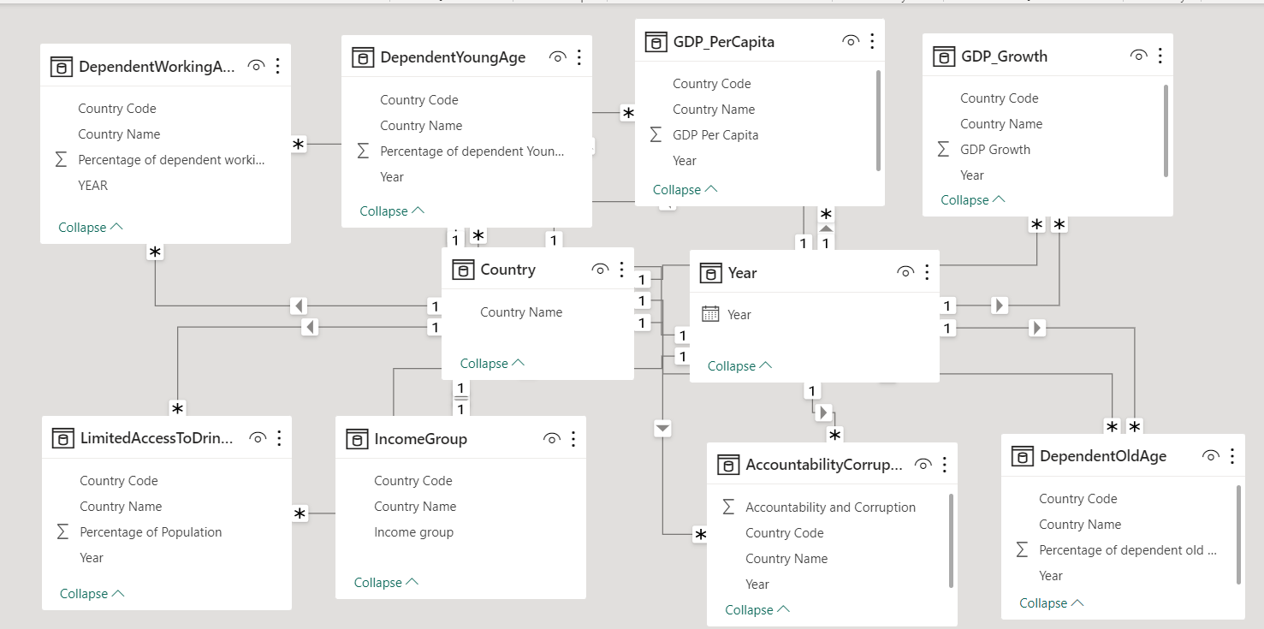

**DATA INSIGHTS AND RECOMMENDATIONS**

1. **DRINKING WATER**

**Visualization**

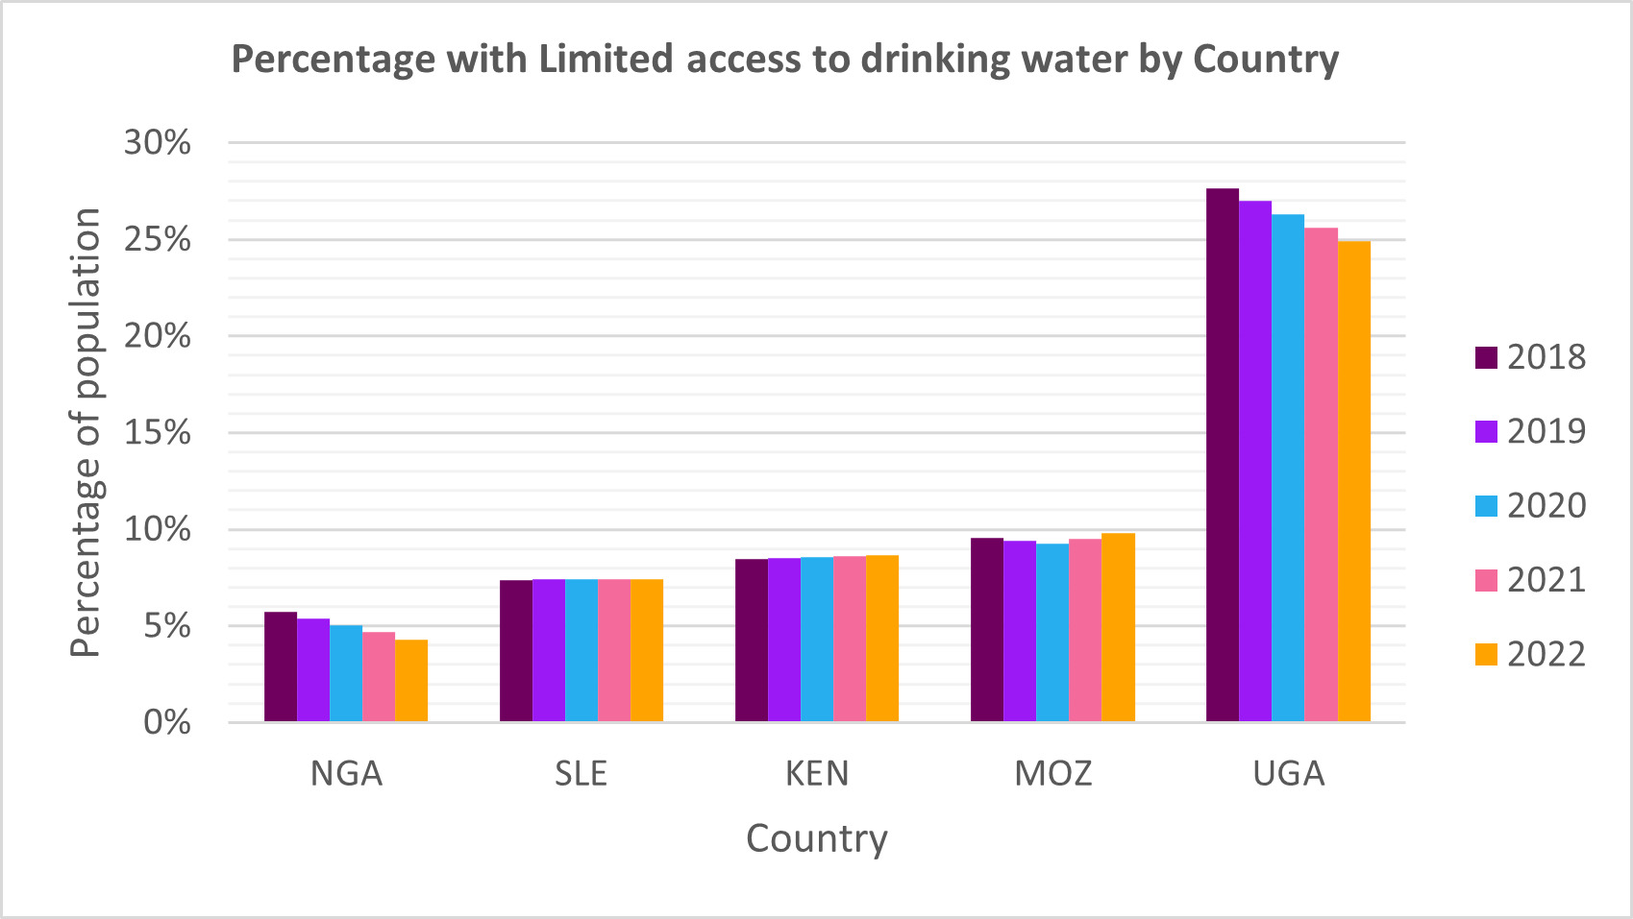

**Insights**

Uganda has the highest population with limited access to drinking water.

**Recommendations**

* 1. **Infrastructure Investment:** Advocate for increased investment in water infrastructure in Uganda. This includes building and maintaining water treatment plants, pipelines, and distribution systems. Access to clean water should be expanded to reach underserved communities.
  2. **Public Awareness:** Promote public awareness campaigns to educate Ugandans about the importance of clean water and proper sanitation practices. Encourage people to use safe water sources and practice good hygiene.
  3. **Government Policies:** Advocate for policies and regulations that ensure equitable access to clean water. Lobby for the implementation of laws that protect water sources from contamination and ensure that water is affordable for all income levels.
  4. **International Aid:** Seek international aid and partnerships to support water access initiatives in Uganda. Many organizations, including non-governmental organizations (NGOs) and international development agencies, work on improving access to clean water in developing countries.
  5. **Community Engagement:** Involve local communities in the planning and management of water resources. Community-based water management can lead to sustainable solutions tailored to the specific needs of each community.

1. **SANITATION**

**Visualization**

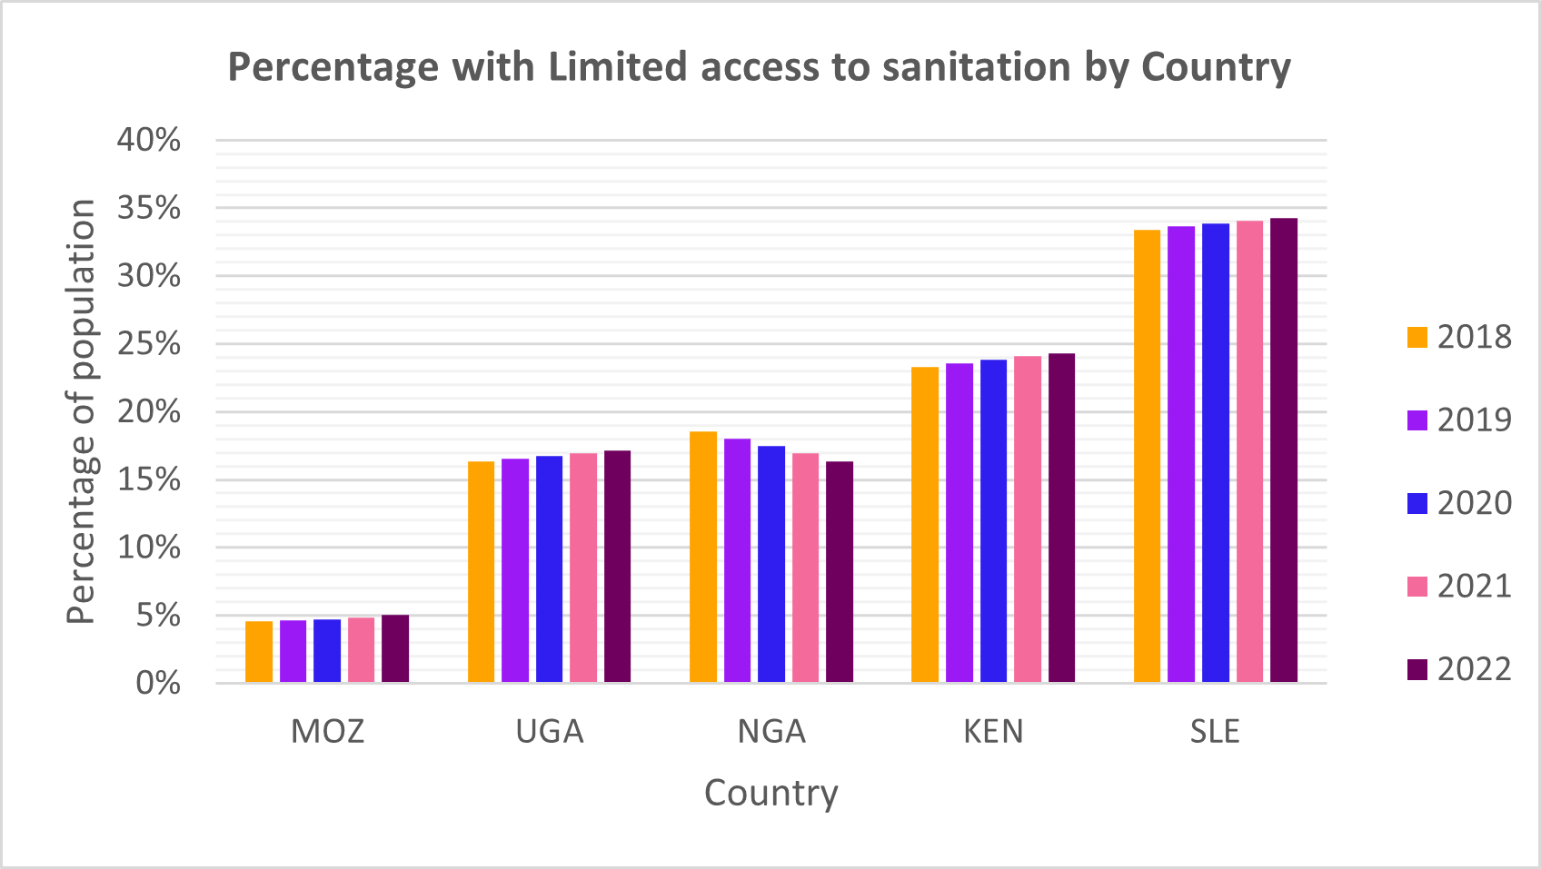

**Insights**

Sierra Leone has the highest member of its population with limited access to sanitation.

**Recommendations**

1. **Sanitation Infrastructure Development:** Advocate for increased investment in sanitation infrastructure in Sierra Leone. This includes the construction and maintenance of sewage systems, toilets, and waste treatment facilities. Ensure that sanitation facilities are accessible to both urban and rural communities.
2. **Promote Hygiene Education:** Launch public awareness campaigns to educate Sierra Leoneans about the importance of proper sanitation and hygiene practices. Encourage behaviors like handwashing, safe waste disposal, and the use of sanitary toilets.
3. **Government Policies and Regulations:** Advocate for the development and enforcement of sanitation policies and regulations. These should include standards for sanitation facilities, waste management, and sanitation in public places. Ensure that these policies are implemented effectively.
4. **International Aid and Partnerships:** Seek international aid and collaborate with organizations, NGOs, and development agencies to support sanitation initiatives in Sierra Leone. Many international organizations focus on improving sanitation and hygiene in developing countries.
5. **Community-Led Sanitation:** Promote community-led sanitation initiatives, which involve local communities in planning, building, and maintaining sanitation facilities. Engage community leaders and local organizations to take ownership of sanitation projects.
6. **Safe Waste Management:** Address the issue of waste management by developing efficient waste collection and disposal systems. Encourage recycling and safe disposal practices to reduce environmental pollution.
7. **AGE DEPENDENCY RATIO**

**Visualization**

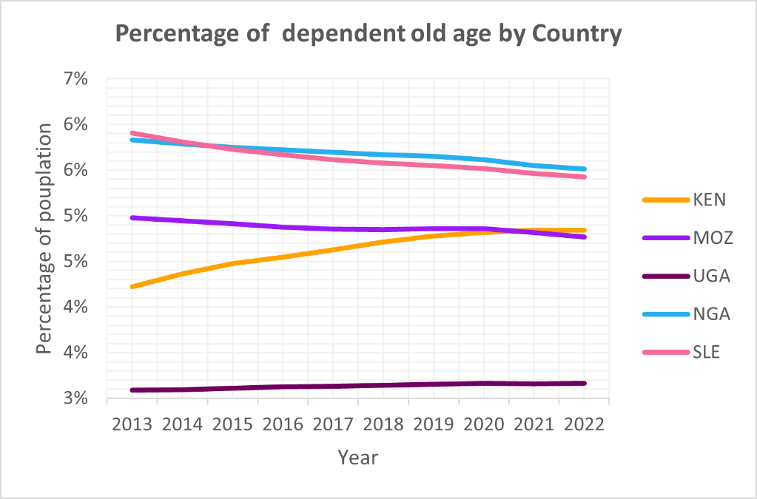

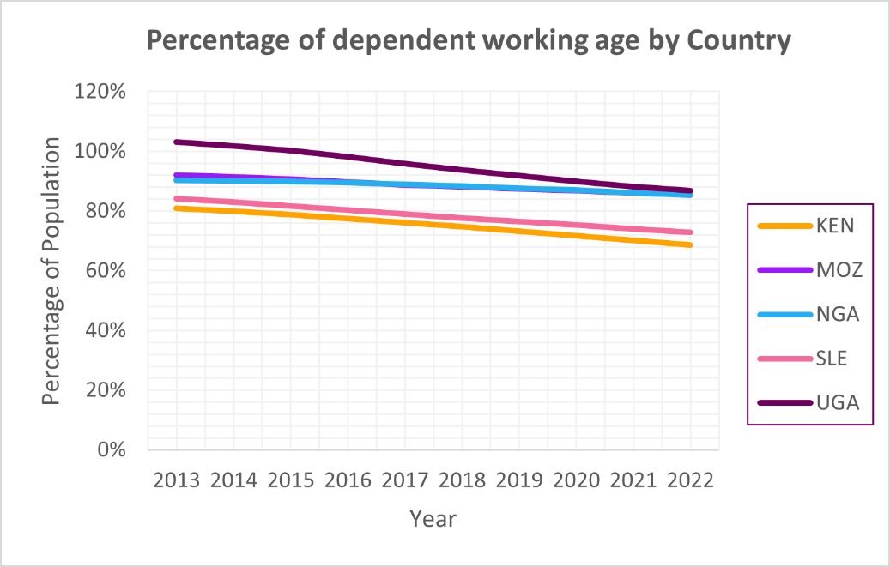

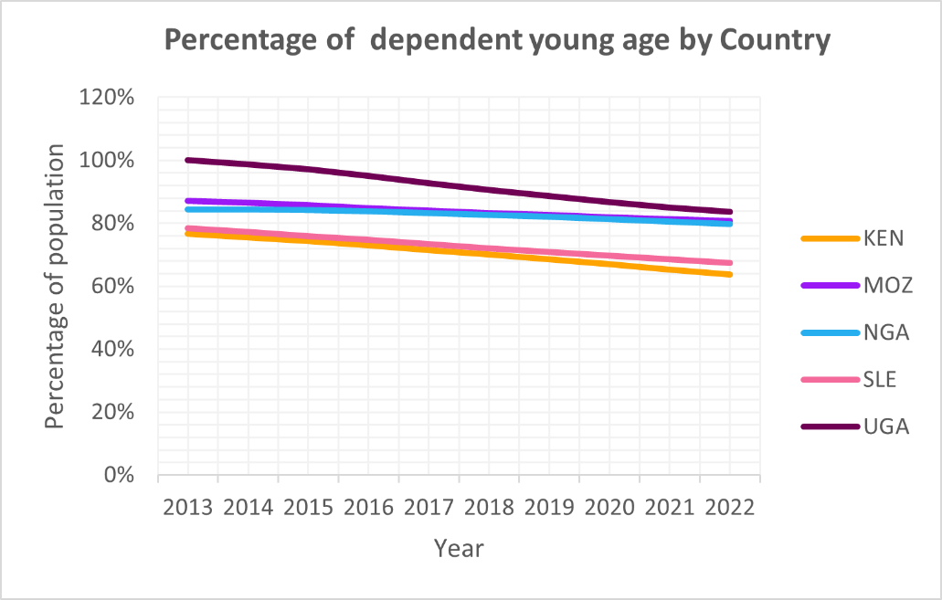

**Insights**

* Uganda, Mozambique, and Nigeria have the highest working age that is dependent while Kenya has the lowest working age that is dependent.
* Nigeria and Kenya have the highest old-age that are dependent while Uganda has the least old-age that are dependent.
* Uganda, Mozambique, and Nigeria have the highest young age that is dependent while Kenya has the least young age that is dependent.

**The causes of the high dependency ratio include**

High Birth Rates, High Maternal and Child Mortality Rates, Limited Educational Opportunities, Economic Factors, Social and Cultural Factors, Lack of Social Welfare Programs, Health Issues, Limited Pension and Social Security Systems, Lack of Adequate Healthcare for the Elderly, Traditional Family Structures, Insufficient Retirement Savings.

**Recommendations**

1. **Education and Empowerment:**

Invest in education, particularly for women and girls, as higher education levels are often associated with lower fertility rates and delayed childbearing.

1. **Healthcare Access:**

Improve access to quality healthcare services, including maternal and child health services, to reduce child mortality rates and improve overall health.

1. **Economic Development:**

Foster economic growth and job creation to increase employment opportunities for the working-age population, reducing economic dependency.

1. **Social Safety Nets:**

Establish or expand social welfare programs and safety nets to provide support for vulnerable populations, including the elderly, children, and people with disabilities.

1. **Pension and Retirement Planning:**

Develop and expand formal pension and retirement savings systems to reduce the financial burden on the working-age population when supporting the elderly.

1. **Gender Equality and Women's Empowerment:**

Promote gender equality, as empowered women often have smaller families and can contribute more effectively to the workforce.

1. **Awareness and Education:**

Raise awareness about the benefits of smaller family sizes and the importance of planning for old age through savings and investments.

1. **Health Promotion:**

Implement health promotion and disease prevention programs to improve overall health and reduce the burden of healthcare costs.

1. **Investment in Youth:**

Provide opportunities for skill development, education, and training for young people to prepare them for the workforce and encourage delayed childbearing.

1. **Migration Policies:**

Develop and implement migration policies that balance the movement of people within and outside the country, taking into account labor needs and demographic trends.

1. **Research and Data Collection:**

Continuously monitor demographic trends and conduct research to better understand the changing population dynamics and inform policymaking.

1. **UNEMPLOYMENT RATE**

**Visualization**

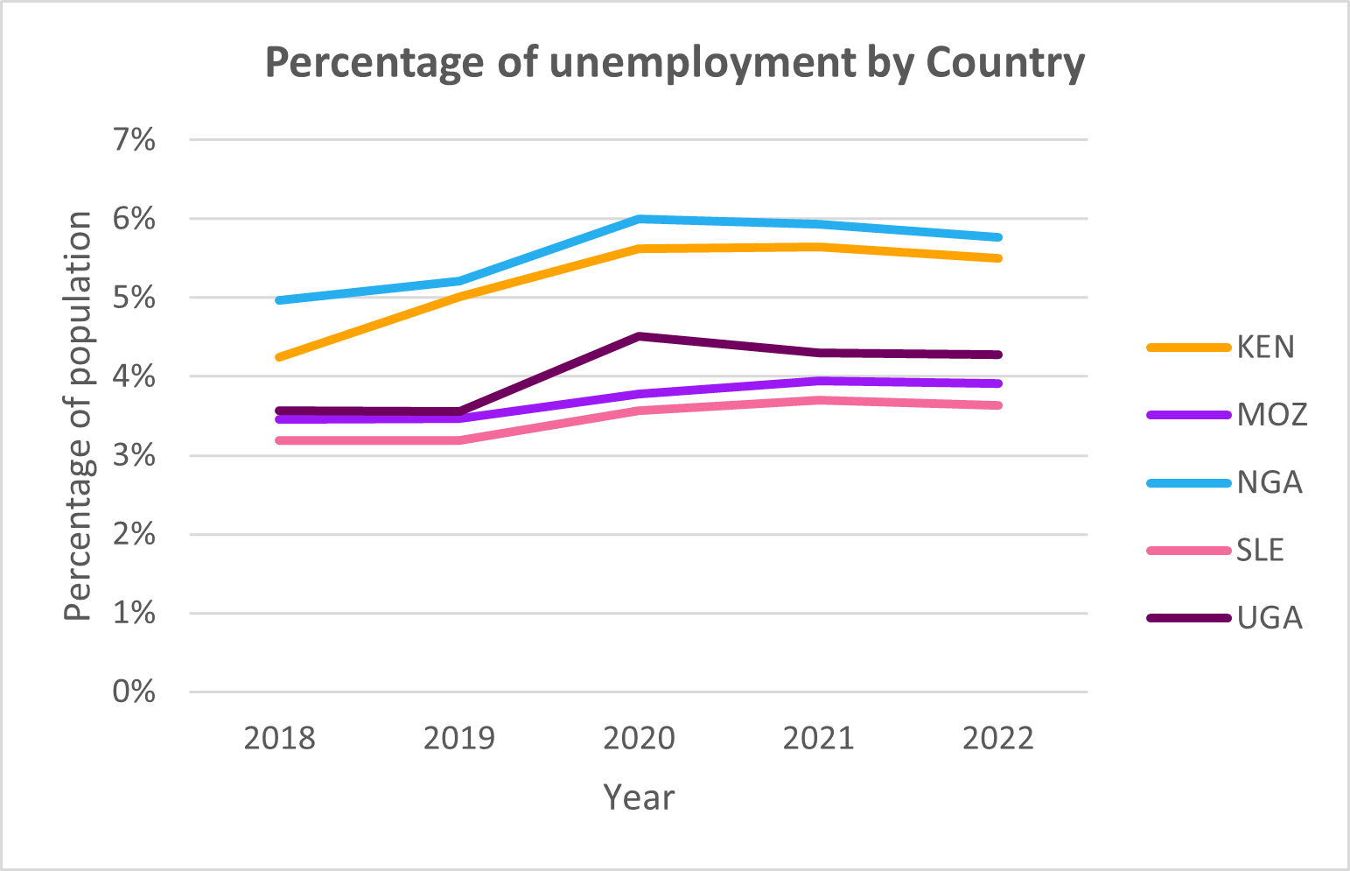

**Insights**

Nigeria and Kenya have the highest percentage of their population unemployed.

**Recommendations**

* 1. **Promote Economic Diversification:**

Encourage economic diversification to create opportunities in various sectors beyond traditional industries. This can include support for small and medium-sized enterprises (SMEs) and the development of emerging industries such as technology and renewable energy.

* 1. **Improve Education and Skills Development:**

Invest in education and vocational training programs that equip individuals with the skills needed for available job opportunities. Collaborate with educational institutions and the private sector to align curricula with market demands.

* 1. **Support Entrepreneurship and Start-ups:**

Foster a culture of entrepreneurship and innovation by providing incentives and support for start-ups. This can include access to financing, mentorship, and a conducive regulatory environment.

* 1. **Infrastructure Development:**

Invest in infrastructure projects that create jobs directly and support economic growth. This can include transportation, energy, and digital infrastructure.

* 1. **Labor Market Reforms:**

Review and reform labor market policies to make it easier for businesses to hire and fire employees. Labor market flexibility can encourage job creation.

* 1. **Targeted Youth Employment Programs:**

Develop programs specifically designed to address youth unemployment, which is often higher than the overall unemployment rate. These can include internships, apprenticeships, and training programs.

1. **INCOME GROUP**

**Visualization**

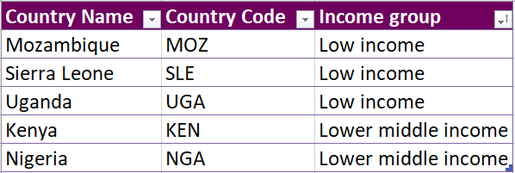

**Insights:**

Mozambique, Sierra Leone, and Uganda are Low-income countries while Nigeria and Kenya are Lower middle-income countries.

**Recommendations**

**For Low-Income Countries (Mozambique, Sierra Leone, and Uganda)**

1. **Economic Diversification:** Focus on diversifying the economy to reduce dependence on a few key sectors. Encourage the growth of industries such as agriculture, manufacturing, and services to create employment opportunities.
2. **Invest in Infrastructure:** Develop and maintain infrastructure, including roads, energy, and telecommunications, to support economic growth and improve connectivity within and outside the country.
3. **Agricultural Development:** Invest in modernizing the agricultural sector to enhance food security and increase the income of rural populations, who often constitute a significant portion of the poor.
4. **Access to Education:** Prioritize access to quality education and vocational training to improve human capital and prepare the workforce for emerging job opportunities.
5. **Healthcare Services:** Ensure access to basic healthcare services and focus on health promotion to reduce the disease burden and increase productivity.
6. **Microfinance and Small Business Support:** Promote microfinance and provide support for small and medium-sized enterprises (SMEs) to stimulate entrepreneurship and local economic development.
7. **Social Safety Nets:** Establish or strengthen social safety nets to provide assistance to the most vulnerable populations, ensuring basic needs are met.

**For Lower Middle-Income Countries (Nigeria and Kenya)**

1. **Economic Growth:** Focus on strategies to further boost economic growth and diversify the economy to advance from lower-middle-income status to upper-middle-income status.
2. **Infrastructure Investment:** Continue to invest in infrastructure development, including transportation, energy, and digital infrastructure, to enhance economic opportunities and connectivity.
3. **Manufacturing and Export Promotion:** Support the growth of manufacturing industries and promote exports to strengthen the international trade position and create more jobs.
4. **Education and Skills Development:** Enhance education and skills development to meet the evolving demands of the labor market and improve human capital.
5. **Access to Finance:** Facilitate access to financing for entrepreneurs, SMEs, and startups, ensuring that capital is readily available for business expansion and innovation.
6. **Good Governance:** Promote transparency, reduce corruption, and enhance governance to create a favorable business environment and attract investments.
7. **Inclusive Growth:** Ensure that economic growth benefits a broad section of the population, addressing income inequality and reducing poverty.
8. **ACCOUNTABILITY AND CORRUPTION**

**Visualization**

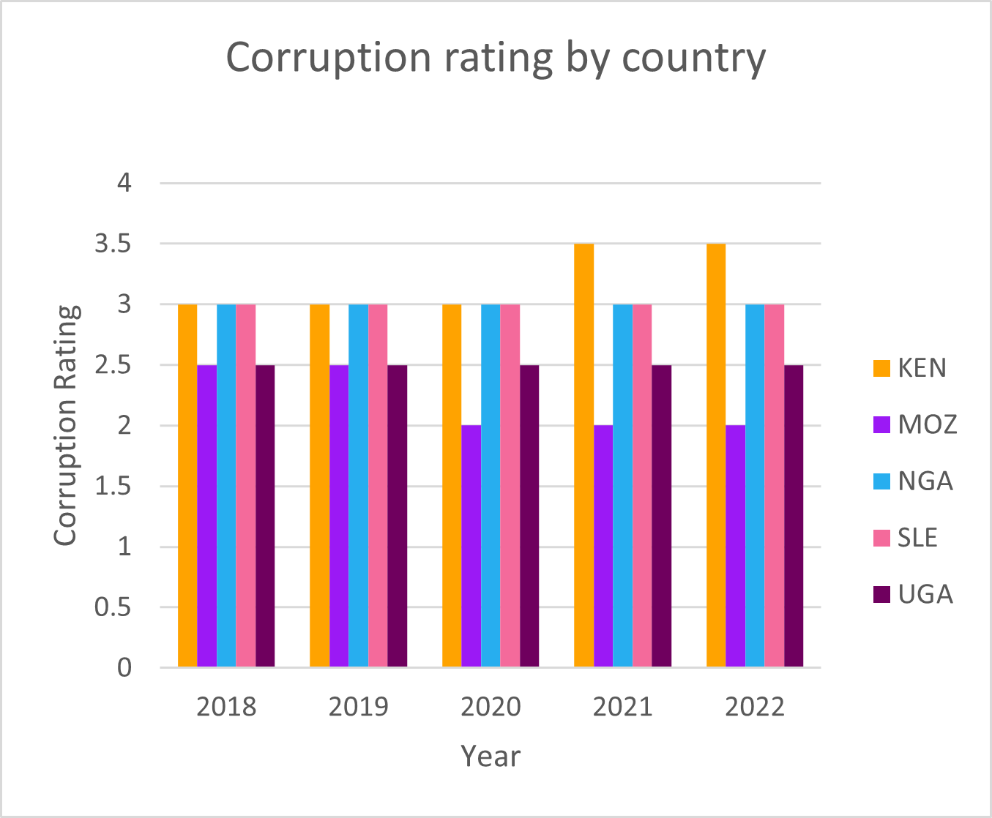

**Insights**

The corruption index across the selected countries has an average of 3 (middle of the index) signifying that there have been some corrupt practices that have been built and sustained over the years. This implies misallocation of public resources; whereby investments in poverty reduction are delayed or insufficient contributing to the poverty rate.

**Recommendations**

Policies and measures should be put in place to ensure that allocated funds for essential services such as education, healthcare, and infrastructure are not diverted for personal gain or channeled into corrupt projects.

1. **GDP GROWTH**

**Visualization**

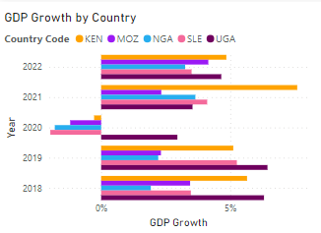

**Insights**

There has been a fluctuation in the GDP growth percentage within the years explored. This infers that there was slower economic activity, which can lead to fewer job opportunities and higher employment rate 2020 was a peculiar year as most of the studied countries experienced a negative GDP growth indicating that the total economic output significantly decreased over a specific period, i.e. fewer production of goods and services due to COVID and other global crisis

These low GDP growth over the years infers a deterred domestic and foreign investment which in turn leads to economic opportunities being constrained. This hinders the government's ability to invest in and expand access to essential services such as healthcare, education, and clean water. This can disproportionately affect low-income individuals and communities thus contributing in the poverty rate.

**Recommendations**

Government can increase spending on infrastructure projects, education, healthcare, and other public goods and services. This boosts demand in the economy, creates jobs, and stimulates economic activity.

Investing in education and skill development programs can improve the quality of the workforce, making it more attractive for businesses to invest and expand in the country.

1. **GDP PER CAPITA**

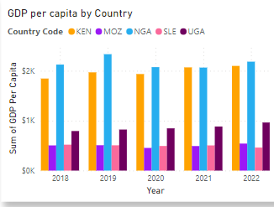

**Insights**

1. **Sierra Leone (Smallest GDP per capita)**

a) Sierra Leone has the lowest GDP per capita among the five countries.

b) It faces significant economic challenges, which may include high poverty rates, limited access to basic services, and development needs.

2. **Mozambique**

a) Mozambique's GDP per capita is higher than Sierra Leone but still relatively low.

b) The country may be in a stage of economic development characterized by ongoing challenges, such as infrastructure development and poverty reduction efforts.

3. **Uganda**

a) Uganda has a higher GDP per capita compared to Mozambique.

b) It might be experiencing moderate economic development, with some improvements in income levels and living standards.

4. **Kenya**

a) Kenya's GDP per capita is higher than Uganda's, indicating a more developed economy.

b) The country may have a larger middle class, better infrastructure, and more diversified economic activities.

5. **Nigeria (Highest GDP per capita)**

a) Nigeria boasts the highest GDP per capita among the five countries.

b) It may be considered an economic powerhouse in the region, with more extensive industries, services, and potentially a larger urban population.

**Recommendations**

To stop or eradicate poverty effectively based on the GDP per capita rankings we provided, which range from lowest (Sierra Leone) to highest (Nigeria), consider the following recommendations:

* 1. **Poverty Alleviation Programs:** Focus on targeted poverty alleviation programs in countries with the lowest GDP per capita, such as Sierra Leone and Mozambique. These programs can include cash transfers, food assistance, and vocational training to help the poorest populations.
  2. **Economic Diversification:** Encourage economic diversification in countries with lower GDP per capita. Help them reduce dependency on a single industry or export by investing in and developing other sectors to create more job opportunities.
  3. **Agricultural Development:** Support agricultural development in these countries, as it often plays a crucial role in reducing rural poverty. Investments in modern farming techniques, infrastructure, and access to markets can enhance agricultural productivity.
  4. **Access to Education:** Prioritize access to quality education, especially in countries with lower GDP per capita. Education is a pathway out of poverty, and improving educational systems can lead to better job prospects.
  5. **Access to Healthcare:** Ensure affordable and accessible healthcare services to prevent families from falling into poverty due to medical expenses. Healthier populations are more productive and economically secure.
  6. **Microfinance and Small Business Support:** Promote microfinance initiatives and provide support for the growth of small businesses, particularly in countries like Sierra Leone and Mozambique. These initiatives can stimulate entrepreneurship and income generation.
  7. **Infrastructure Development:** Invest in basic infrastructure, such as roads, electricity, and clean water, to improve living conditions and stimulate economic growth in impoverished areas.

**DASHBOARD**

**Dashboard inspiration:** behance.net

**Colour inspiration:** coolor.co

**Slide images:** Pininterest

**Dashboard size:** 1500px by 800px

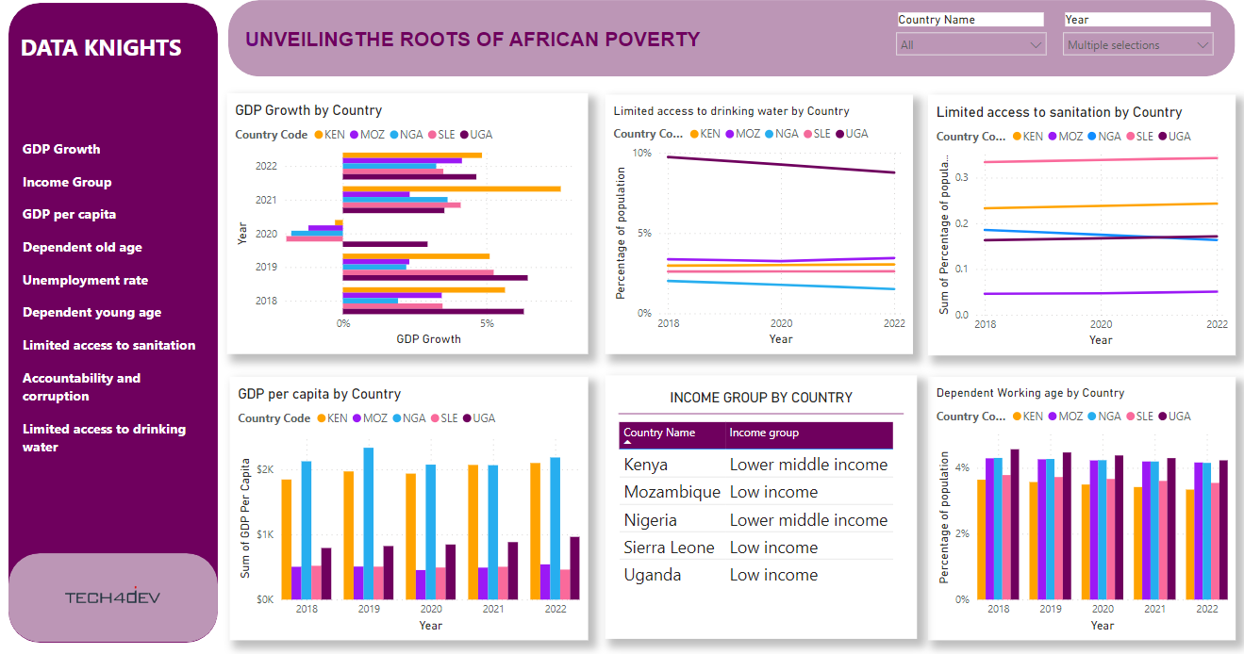

**DASHBOARD WIREFRAME**

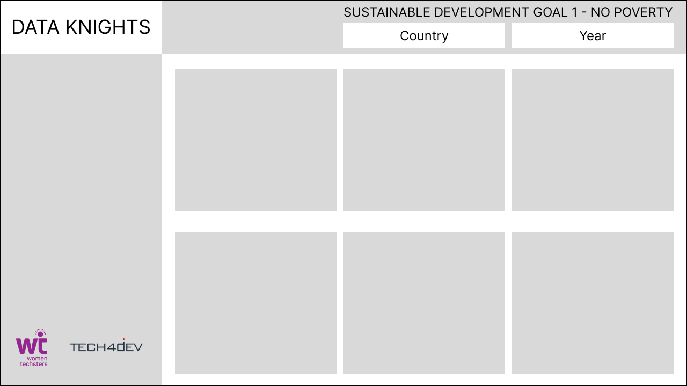

**VISUAL COLOURS**

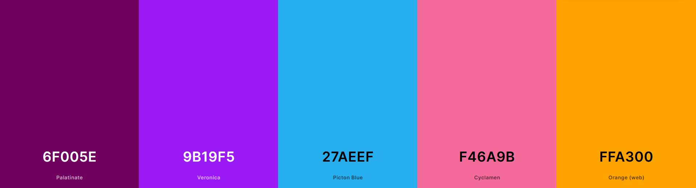

UGA PURPLE 6F005E

MOZ BLUE 9B19F5

NGA CYAN 27AEEF

SLE PINK F46A9B

KEN ORANGE FFA300

UGA PURPLE 6F005E

MOZ BLUE 9B19F5

NGA CYAN 27AEEF

SLE PINK F46A9B

KEN ORANGE FFA300

DASHBOARD**:** BC96B6

**DASHBOARD COLOUR: BC96B6**

**DASHBOARD COLOUR:** BC96B6

**DATA FIELD LIST**

1. GDP Growth
2. Income Group
3. GDP per capita
4. Dependent old age
5. Unemployment rate
6. Dependent young age
7. Limited access to sanitation
8. Accountability and corruption
9. Limited access to drinking water